Question 1
### !a) Describe the dataset
library(MASS)
data(crabs)
str(crabs)
summary(crabs)
Output:
> summary(crabs)
sp sex index FL RW
B:100 F:100 Min. : 1.0 Min. : 7.20 Min. : 6.50
O:100 M:100 1st Qu.:13.0 1st Qu.:12.90 1st Qu.:11.00
Median :25.5 Median :15.55 Median :12.80
Mean :25.5 Mean :15.58 Mean :12.74
3rd Qu.:38.0 3rd Qu.:18.05 3rd Qu.:14.30
Max. :50.0 Max. :23.10 Max. :20.20
CL CW BD
Min. :14.70 Min. :17.10 Min. : 6.10
1st Qu.:27.27 1st Qu.:31.50 1st Qu.:11.40
Median :32.10 Median :36.80 Median :13.90
Mean :32.11 Mean :36.41 Mean :14.03
3rd Qu.:37.23 3rd Qu.:42.00 3rd Qu.:16.60
Max. :47.60 Max. :54.60 Max. :21.60

1b)
# Load the MASS package
library(MASS)

# Load the crabs dataset
data(crabs)

# Display the structure of the dataset
str(crabs)

Output:
# Load the crabs dataset
> data(crabs)
>
> # Display the structure of the dataset
> str(crabs)
'data.frame': 200 obs. of 8 variables:
$ sp : Factor w/ 2 levels "B","O": 1 1 1 1 1 1 1 1 1 1 ...
$ sex : Factor w/ 2 levels "F","M": 2 2 2 2 2 2 2 2 2 2 ...
$ index: int 1 2 3 4 5 6 7 8 9 10 ...
$ FL : num 8.1 8.8 9.2 9.6 9.8 10.8 11.1 11.6 11.8 11.8 ...
$ RW : num 6.7 7.7 7.8 7.9 8 9 9.9 9.1 9.6 10.5 ...
$ CL : num 16.1 18.1 19 20.1 20.3 23 23.8 24.5 24.2 25.2 ...
$ CW : num 19 20.8 22.4 23.1 23 26.5 27.1 28.4 27.8 29.3 ...
$ BD : num 7 7.4 7.7 8.2 8.2 9.8 9.8 10.4 9.7 10.3 ...

>

1c)
### 1c)
# Load MASS package
library(MASS)

# Load dataset
data(crabs)

# Frequency table for species
table(crabs$sp)

# Frequency table for sex
table(crabs$sex)
# Cross-tabulation (Species by Sex)
table(crabs$sp, crabs$sex)
OUTPUT:
> ### 1c)
> # Load MASS package
> library(MASS)
>
> # Load dataset
> data(crabs)
>
> # Frequency table for species
> table(crabs$sp)

B O
100 100
>
> # Frequency table for sex
> table(crabs$sex)

F M
100 100
>
> # Cross-tabulation (Species by Sex)
> table(crabs$sp, crabs$sex)

F M
B 50 50
O 50 50

1d.
# Bar plot
barplot(tab,
beside = TRUE,
col = c("skyblue", "salmon"),
legend = rownames(tab),
main = "Bar Chart of Species by Sex",
xlab = "Sex",
ylab = "Frequency")
OUTPUT:
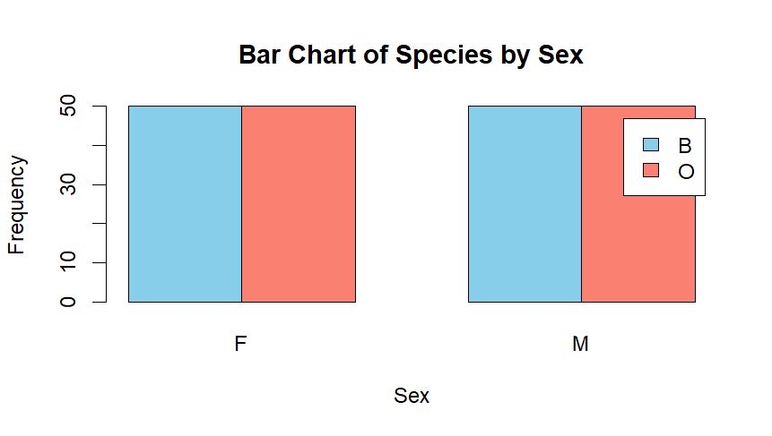
1e.
The crabs dataset is perfectly balanced across the four species–sex groups, with 50 observations in each group. This results in a balanced 2 × 2 factorial design, which is ideal for comparative and multivariate statistical analysis.

Question 2
2a.
# Load MASS package
library(MASS)

# Load dataset
data(crabs)

# Create combined group variable
crabs$group <- interaction(crabs$sp, crabs$sex)

# Side-by-side boxplots
boxplot(BD ~ group,
data = crabs,
col = c("skyblue", "lightgreen", "salmon", "orange"),
main = "Body Depth (BD) by Species and Sex",
xlab = "Species and Sex Groups",
ylab = "Body Depth (mm)")
OUTPUT:
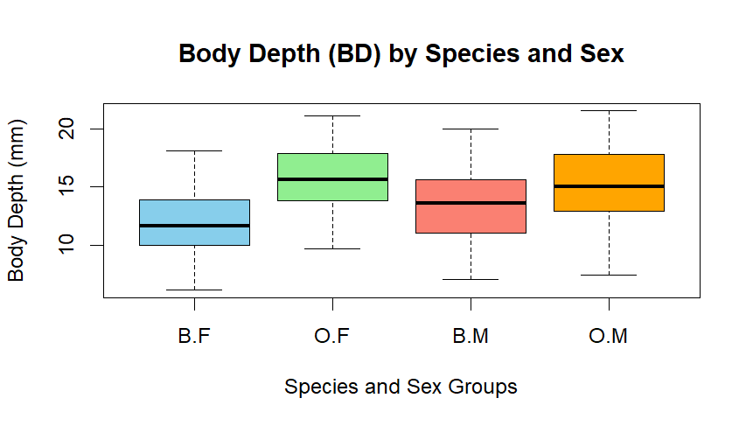
2b.
The side-by-side boxplots show minimal evidence of extreme outliers across the four species–sex groups. The median body depth is higher for males than females in both species, indicating a strong sex effect. Differences between species are less pronounced than differences between sexes. The interquartile ranges are similar across groups, although male groups exhibit slightly greater variability. Overall, body depth appears more strongly associated with sex than species.

Question 3
3a.
# Load MASS package
# Load dataset
data(crabs)
library(MASS)

# Set plotting area for side-by-side plots
par(mfrow = c(1, 2))

# Histogram for Blue species
hist(crabs$CL[crabs$sp == "B"],
main = "Histogram of CL (Blue Species)",
xlab = "Carapace Length (mm)",
col = "skyblue",
border = "black")

# Histogram for Orange species
hist(crabs$CL[crabs$sp == "O"],
main = "Histogram of CL (Orange Species)",
xlab = "Carapace Length (mm)",
col = "salmon",
border = "black")

# Reset plotting area
par(mfrow = c(1, 1))
OUTPUT:
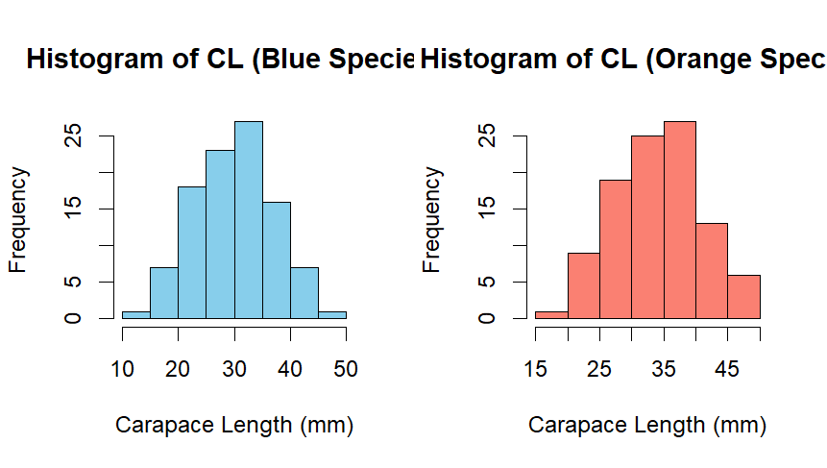
3b.
The histograms of carapace length for both Blue and Orange species are approximately symmetric and roughly bell-shaped, suggesting near-normal distributions. There is no strong evidence of skewness in either species. However, mild bimodality may be observed, which is likely attributable to the inclusion of both male and female crabs within each species. Overall, the shapes of the two species distributions are very similar.

QUESTION 4
4a.
library(dplyr)

crabs %>%
group_by(sp, sex) %>%
summarise(across(c(FL, RW, CL, CW, BD), mean), .groups = "drop")

output:
> crabs %>%
+ group_by(sp, sex) %>%
+ summarise(across(c(FL, RW, CL, CW, BD), mean), .groups = "drop")
# A tibble: 4 × 7
sp sex FL RW CL CW BD
<fct> <fct> <dbl> <dbl> <dbl> <dbl> <dbl>
1 B F 13.3 12.1 28.1 32.6 11.8
2 B M 14.8 11.7 32.0 36.8 13.4
3 O F 17.6 14.8 34.6 39.0 15.6
4 O M 16.6 12.3 33.7 37.2 15.3

4b.
# Load MASS package
library(MASS)

# Load dataset
data(crabs)

# Compute group means
means <- aggregate(cbind(FL, RW, CL, CW, BD) ~ sp + sex,
data = crabs,
FUN = mean)

# Create group labels
means$group <- paste(means$sp, means$sex, sep = ".")

# Create matrix of means (rows = measurements, columns = groups)
mean_matrix <- t(as.matrix(means[, 3:7]))
colnames(mean_matrix) <- means$group

# Grouped bar chart
barplot(mean_matrix,
beside = TRUE,
col = c("skyblue", "salmon", "lightgreen", "orange", "purple"),
legend.text = rownames(mean_matrix),
args.legend = list(x = "topright"),
main = "Mean Morphological Measurements by Species and Sex",
xlab = "Species and Sex Groups",
ylab = "Mean Value")

OUTPUT:
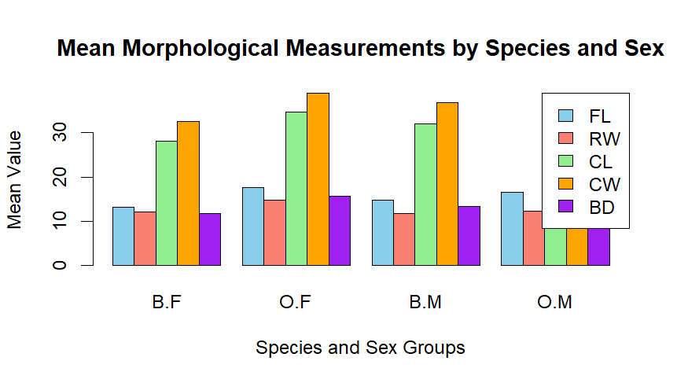

4c.
library(MASS)
library(dplyr)

data(crabs)

# Compute means by species and sex
means <- crabs %>%
group_by(sp, sex) %>%
summarise(across(c(FL, RW, CL, CW, BD), mean), .groups = "drop")

means
output:
# A tibble: 4 × 7
sp sex FL RW CL CW BD
<fct> <fct> <dbl> <dbl> <dbl> <dbl> <dbl>
1 B F 13.3 12.1 28.1 32.6 11.8
2 B M 14.8 11.7 32.0 36.8 13.4
3 O F 17.6 14.8 34.6 39.0 15.6
4 O M 16.6 12.3 33.7 37.2 15.3

>

Species differences (averaging over sex)
species_means <- crabs %>%
group_by(sp) %>%
summarise(across(c(FL, RW, CL, CW, BD), mean))

species_diff <- abs(species_means[1, -1] - species_means[2, -1])
species_diff
output:
FL RW CL CW BD
1 3.054 1.621 4.095 3.395 2.895

Sex difference(averaging over species)

sex_means <- crabs %>%
group_by(sex) %>%
summarise(across(c(FL, RW, CL, CW, BD), mean))

sex_diff <- abs(sex_means[1, -1] - sex_means[2, -1])
sex_diff

output:
FL RW CL CW BD
1 0.302 1.497 1.491 1.169 0.613

Answer:
Carapace Width (CW) exhibits the greatest difference between species, indicating it is most sensitive to species variation. Frontal Lobe (FL) shows the least variation between sexes, suggesting that sexual dimorphism has the smallest effect on this measurement compared to the others.

# Define colours by species
cols <- ifelse(crabs$sp == "B", "skyblue", "salmon")

pairs(measurements,
main = "Scatterplot Matrix by Species",
pch = 19,
col = cols)
output:


5a.
# Load MASS package
library(MASS)

# Load dataset
data(crabs)

# Select the five measurements
measurements <- crabs[, c("FL", "RW", "CL", "CW", "BD")]

# Produce scatterplot matrix
pairs(measurements,
main = "Scatterplot Matrix of Crab Morphological Measurements",
pch = 19,
col = "darkblue")
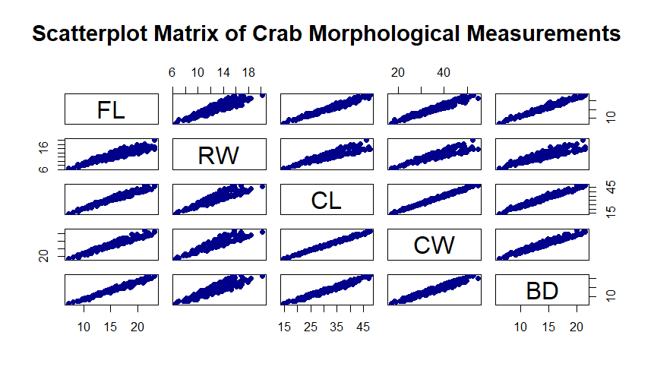
5b.
The five morphological measurements (FL, RW, CL, CW, BD) exhibit strong to very strong positive linear relationships. The scatterplot matrix shows clear upward linear trends with tight clustering of points, indicating high correlations among the variables. This suggests that the measurements reflect overall crab size and increase proportionally. There is no evidence of nonlinear relationships or weak associations among the continuous variables.

QUESTION 6

Statistical Analysis of the Crabs Dataset

1. Introduction
This report presents an exploratory statistical analysis of the crabs dataset obtained from the MASS package in R. The dataset comprises morphological measurements of 200 crabs of the species Leptograpsus variegatus, classified according to colour morph (Blue and Orange) and sex (Male and Female). Five continuous morphological variables were recorded for each crab: frontal lobe size (FL), rear width (RW), carapace length (CL), carapace width (CW), and body depth (BD), all measured in millimetres.
The primary objective of this analysis is to examine the distributional properties of the variables, assess differences across species and sex, and evaluate the strength and nature of relationships among the morphological measurements.

2. Structure and Distribution of Categorical Variables
Inspection of the dataset structure indicates a balanced design, with equal representation of species and sex categories. Cross-tabulation of species and sex confirms equal frequencies across all four species–sex combinations. The mosaic plot further supports the absence of any apparent association between species and sex, as the cell proportions are uniform.
This balanced structure enhances comparability across groups and reduces the risk of confounding due to unequal sample sizes.

3. Morphological Differences Across Species and Sex
Side-by-side boxplots and group means were used to evaluate differences in morphological measurements across species and sex. The results indicate systematic, though moderate, variation between groups.
When averaging across sex, certain measurements—particularly rear width (RW), carapace length (CL), and carapace width (CW)—exhibit differences between the Blue and Orange species. Similarly, when averaging across species, males generally display slightly larger mean measurements than females across most morphological variables.
However, the magnitude of these differences is modest relative to the overall variability observed in the data. Thus, while both species and sex influence crab morphology, these effects are not dominant sources of variation.

4. Distributional Characteristics of Continuous Variables
Histograms of carapace length (CL) for each species reveal approximately unimodal and roughly symmetric distributions. The shapes of the distributions are broadly similar across species, with substantial overlap. There is no strong evidence of extreme skewness or influential outliers.
These findings suggest comparable growth patterns across species, with differences primarily reflected in location (mean levels) rather than distributional shape.

5. Relationships Among Morphological Measurements
The central focus of the analysis concerns the relationships among the five continuous morphological variables. A scatterplot matrix (pairs plot) reveals strong and consistent positive linear relationships among all measurement pairs.
In particular:
- Carapace length (CL) and carapace width (CW) exhibit an especially strong linear association.
- Body depth (BD) increases proportionally with both CL and CW.
- Frontal lobe size (FL) and rear width (RW) similarly scale with overall body dimensions.
The scatterplots display tight clustering of points around upward-sloping linear patterns, indicating very strong positive correlations. There is no visual evidence of curvature, nonlinearity, or heteroscedasticity. These findings strongly suggest that the five morphological variables reflect a common underlying dimension—overall body size.
The strength of association among these variables substantially exceeds the magnitude of differences attributable to species or sex.

6. Overall Interpretation
The analysis reveals three principal conclusions:
- Species and sex are independent and equally represented in the dataset.
- Both species and sex contribute moderate differences in morphological measurements, with males generally slightly larger than females.
- The most prominent structural feature of the dataset is the very strong positive linear association among the five morphological variables, indicating proportional growth and a shared underlying size factor.
In summary, while categorical group differences exist, the dominant pattern in the data is one of strong internal morphological scaling. The measurements collectively describe overall crab size, and increases in one dimension are accompanied by proportional increases in others.

